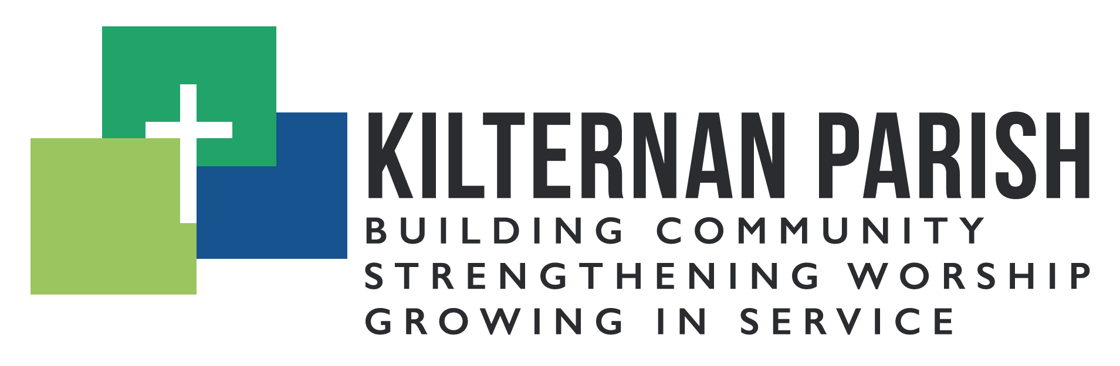
Youth Ministry Co-Ordinator
Background
Kilternan Parish, Church of Ireland, is seeking a Youth Ministry Co-ordinator to join the staff team on a flexible part time basis. The purpose of the role is to develop and support the parish’s work with young people and young adults.
The Youth Ministry Co-ordinator will work closely with the Rector, the staff team, particularly the Children and Family Ministry Coordinator, and the Church Officers. Kilternan Parish is a faith-based organisation within the Church of Ireland tradition. Applicants do not need to be from that tradition, but they would need to be sympathetic to it, and to the parish’s mission of building community, strengthening worship, and growing in service.
Kilternan Parish is a growing parish. The parish 300 families on the parish data base, with a high percentage of young families. Kilternan Youth Ministry has been in effect since 2018 under the leadership of our previous youth worker, including a junior and senior youth group. One of our ambitions is to improve our engagement with young adults. On Sundays we run weekly all age worship, and a monthly Messy Church and Café Church. We have excellent facilities and operate a very successful drop in café called the Gathering Grounds Café. Venue wise, it’s a youth workers dream! We also maintain a primary school with 230 students.
Key Responsibilities
- To strengthen our ministry for young people, including but not limited to regular youth groups.
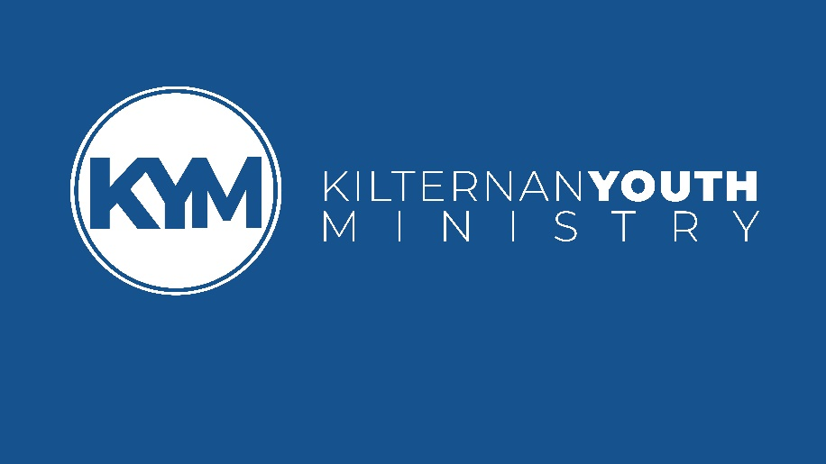
- To support the development of all age worship and other fresh expressions of church. This will involve participation in worship, talks etc.
- To disciple young people so that they can grow in faith and mission. This will include assisting in the annual confirmation programme
- To identify potential volunteers, encourage and mentor them and help establish them in the ministry to young people
- To support the ministry of a monthly Messy Church.
- To support the Rector and Children and Family Ministry coordinator in ministry to the local Primary School, by taking an active role in school assemblies, RE classes, special events, etc.
- To work with the church team in developing a ministry to young adults
- To improve means of communication with young people and parents using social and current forms of media. This will include contributing to church and community publications.
- To support the overall ministry and mission of the parish in building community, strengthening worship and growing in service.
We are looking for someone who:
- Is a spiritually mature Christian with a heart to reach and serve young people.
- Is a team player with a natural ability to relate to young people.
- Is creative, enthusiastic, self-motivated and able to organise themselves and others effectively.
- Has experience of working with young people preferably in a church context.
- Has excellent interpersonal communication skills – written and oral
- Has the ability to work flexibly
- Demonstrates ability to respect matters of confidentiality, sensitivity and compassion
- A current driver’s license is also desirable
Location and Hours
The Youth ministry Coordinator will usually work in the Kilternan Centre.
The role is initially scoped for 20 hours a week (initially a 12-month contract). Flexibility of hours will be required for the post-holder, often including evening meetings and regular Sunday involvement.
Salary negotiable.
C.V and cover letter to Rob Clements at rector@kilternanparish.ie (closing date for applicants 12th August 2022)
For additional information, please contact David Webb at david.webb@protestantaid.org

