Parish Survey
In total 84 people complete the survey.
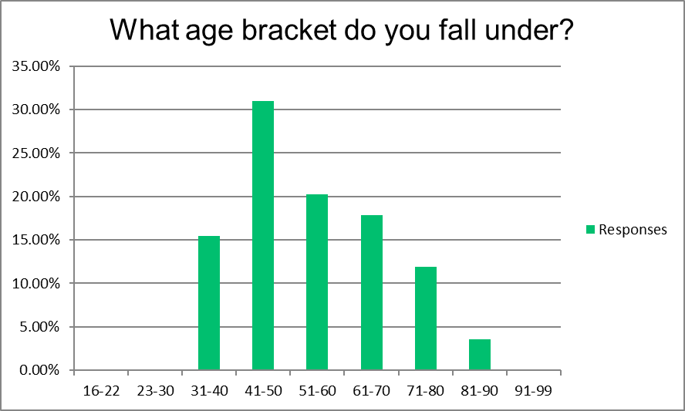

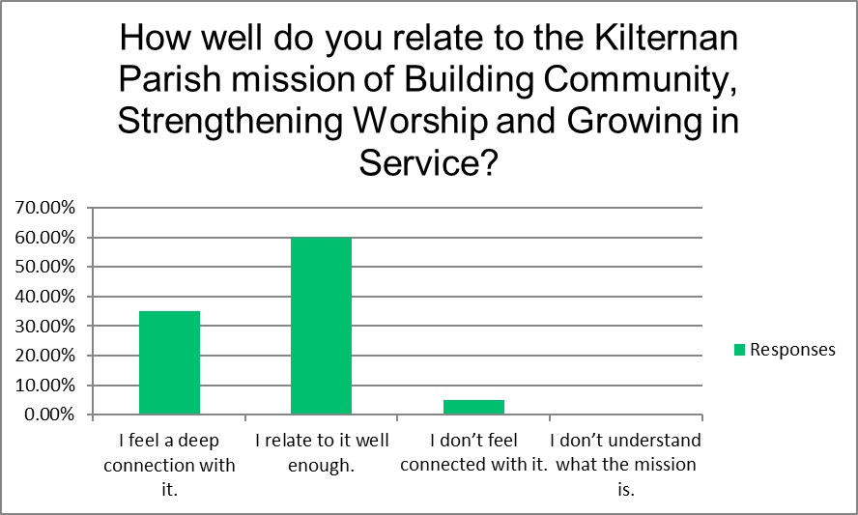

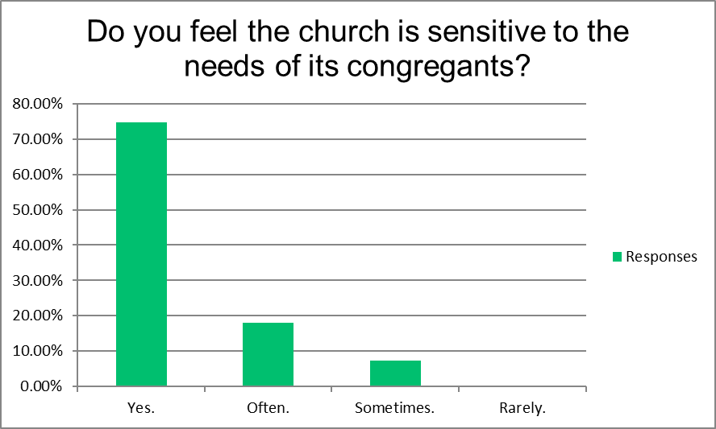

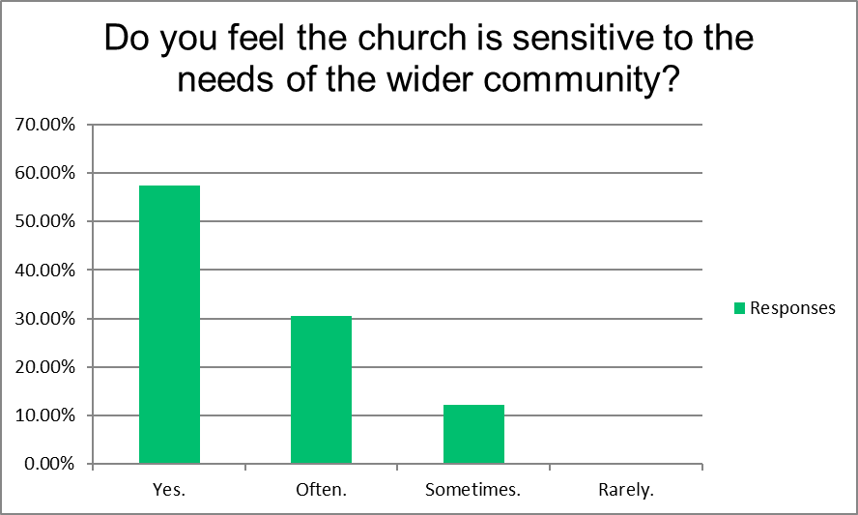

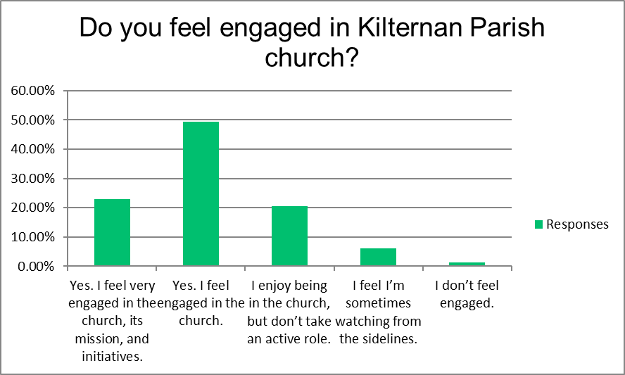

What excites/inspires/motivates you about our current ministries at Kilternan Parish? If nothing comes to mind, what sort of ministries/programs might make you more excited/inspired/motivated?
Sunday worship sermons and music is always inspiring with a good message. Online services and prayer evenings during lockdown kept us well connected
For one not deeply religious but who much appreciates Christian values, I feel that the current ministries are working very well.
I like the inclusiveness of the Parish. Very good at engaging with young children. Always trying and doing new things.
There is something for everybody if they wish to participate
Love that there’s a youth and family representative on the team and love the centre’s activities, availability to the parish and particularly Gathering Grounds
Using the resources of the parish to help the community where there is need
The Gathering Grounds is great for connecting people
The sermons at early communion. The 11:30 communion service in the meeting room. The occasional musical evenings and centre activities. The industry of the rector in explaining the scripture. His willingness to help and to get others involved.
The open and inclusive approach is very refreshing, with the kids' voices being heard as well as the adults, and an honest attempt to listen to everyone. I'm brand new, but that's my first impression.
I think we need to be conscious of families and parents when we arrange events for Sunday afternoons and evenings. This is a time when we need to prepare for return to school and settle kids down for the evening. I think Messy Church and other broad parish get togethers are better suited to Saturday afternoons.
Sense of belonging and community
Fellowship, kindness
Finding listening to the scripture and sermon at Sunday service very inspiring.
I would like to see a return to at least monthly all age services to bring together the entire parish family. Otherwise, there might develop an increasing rift between those attending at 10 versus 9 or 11. Will the current congregation at 10 graduate to the 11 service or will they prefer to stay separate?
A commitment to traditional services whilst engaging in new and innovative ways with the community.
The connection with the community via the school into the Gathering Grounds / services is a great success. The connection with and support for the elderly through the lunches (pre pandemic) was excellent ministry. I would love to see connection with the late teens, 20s and 30s - difficult age groups to connect to. Prayer ministry is a big gap, Christian meditation (reclaim from New Age practices), singles group(s) (these people are so often left out as events are family or couple oriented), Alpha, marriage, parenting courses, Bible studies / homegroups. Programs for the needs of our community (what are those needs...?) - loneliness? mental health? dealing with grief? hunger?
Welcoming attitude particularly in the Gathering Grounds
Opening our doors through the Gathering Grounds, and initiatives like Messy Church are a great way to connect with the community and more ideas like these are essential. I believe that
I love messy church for the kids especially because so many children have sports commitments on a Sunday. The other initiatives of blessing of school bags and pet blessing is great
The way the Gathering Grounds is open to all
Community bases
Messy church/ Sunday morning at gathering grounds / family events motivate and inspire me - the welcome, focus and inclusion that families experience is wonderful. I love that the offering for young children can be welcoming and accessible
Larger community get-togethers
Inspired by Gathering Grounds
I like how Rob relates Christianity to everyday living. I like the family service initiative. I would like to see messy church back
High energies and enthusiasm by all, especially the youth and children’s ministries.
I love the fact that it is so inclusive with our children and we can go as a family. I feel a real sense of community, I can relate to the messages spread during church.
Family & Community activities
Open to innovative ideas to build the community and bring people together
Children ministry
The different format and the fact that it really engages the whole congregation
The inclusivity of the community and the opportunities for the congregation to reach others
Intergenerational worship
The outreach through the Gathering Grounds, seeing a lot more young families coming to church and the buzz that brings, I would be nice to have something that digs a bit deeper into faith and to explore this with fellow parishioners but not everyone would be comfortable with this . I feel i know a lot of parishioners but not really on a faith level
Everything
The Gathering Grounds concept.
We have a forward-looking rector and wife. Perhaps we rely on them too much
Very family orientated
Wellness/Exercise Class for older folk would be appreciated. May have to be outside in the present situation - but something to be considered.
Parish activities allowing you to meet other parishioners and getting warm welcome to all
Youth ministries
Traditional worship,
I'm happy with the way it is
Variety of service options. Would like with parish to get involved in some sort of charitable works.
The message of faith is delivered in a very simple powerful way and what is preached is practiced in the Parish
I/we need to get more involved to feel we have any authority on this matter. Love Christmas get togethers in the parish and will be making an effort to get the whole household to attend
Very happy to see we have a youth ministry, many churches have absolutely nothing! We cater for young children very well but think we need to encourage more teenagers and young adults, especially to make the move from say youth group to the congregation.
Kids ministry
I feel very lucky to be a member of a parish that is innovative, providing family centred worship that meets my young family's needs. I feel that Rob and his team are genuine and enthusiastic which is great.
It is great to see that all ages are being catered for through the various initiatives. The one area that might be improved may be for older adults who have gone through the child and teenager/young adult stage of life but are not yet retired - are there any ideas out there?
Connection with the church and encouragement with our faith. Involvement with various activities attached to the church and the fact that it is inclusive of the wider community.
I look forward to the weekly service - it is uplifting
Openness of the parish centre and all the opportunities it affords. The Gathering Grounds has been an amazing success on many levels
I enjoy Robs sermons
Rob and Julie are so welcoming friendly aura
The way families are encouraged, the huge change in that since Rob and Julie have arrived is remarkable. There are different ways to worship and be part of the community and it doesn’t just have to be on a Sunday morning
The family service and messy church.
Family orientated services
Very family friendly, love the idea of toddler group, Thursday lunches etc
So welcoming and inclusive. You are valued whether you attend church or not
Consistent effort to serve the community and the needy. The commitment to maintain traditional worship alongside newer developments.
The pastor and his family, Messy Church, Parish Cafe
If the parish had access to some land, wouldn’t it be lovely to develop a community garden which could be cultivated and developed across the generations. This could connect generations, provide a sense of purpose, curiosity, and gratefulness. Some older parishioners have so much to offer to some of the younger folk.
Fellowship
Leniency towards ecumenism also involvement with young families and school families
Expanding to include younger families. Engaging with the new communities springing up around us. Use of the Centre by diverse groups of the community. Social / wellbeing aspect of the Gathering Grounds.
There is a deep sense of community & belonging. It is a very welcoming environment
It's modern and outward reaching
Something that caters for families with older children - lots for young families and the empty nesters but feel there can be a gap for families with older teens/young adults
The inspiring sermons, the inclusiveness and non-judgemental approach, the ease of bringing children and making them a relaxed part of worship, messy church, community gatherings and events
Community and belonging. Inclusion of all needs and worship styles.
The weekly contact via newsletter.
Imagine our parish in five years with unlimited resources. What would Kilternan Parish be doing? What would it look like?
Outreach into the Community particularly with all the new developments expected.
Unlimited resources - unlikely and not a good thing anyway as it could take away the drive to put in the individual effort.
Maybe add more sport and social activities. e.g. Regular Table tennis in the hall, bridge night for the parish
After school community group for kids, maybe visiting elderly in the glebe or engaged in other community projects like making care packages for people or something
Hopefully similar to the way it is today, friendly and welcoming
Continue the good work. Continue to be a place of welcome, prayer and giving to others. Have a dependable heating system in the church
It will have a larger congregation and be involved in many outreach programmes. It will have a problem with allowing everyone in the different services to meet and know each other, so the feeling of unity of the congregation will be a problem, but we can all work on that. It will have a variety of service types, and countless other activities involving different interest groups, ages and Christian engagement, but all with a direction towards serving each other and the wider community, and so ultimately serving God.
A bigger version of what it is now
Outreach to young adults and young families
A community based on looking after the different needs of the members of the parish, but also the needs of others outside the parish. Soup kitchen, shelter, citizens advice centre,
The interior of the Church has been made more comfortable - warm and less draughty. A porch has been added at the back. Outreach to the community is increasing; since the opening of the Centre the word has spread, and the greater community (all faiths) have found comfort and friendliness. We have embarked on a community outreach programme outside our Kilternan comfort zone.
I hope it would look like it does now, with increased engagement with the wider community. With the continuing expansion of Kilternan, it would be good to be a real touchstone for people – regardless of their background and affiliation.
Lots of outreach programs in the community. Services and worship of different forms. Home groups, prayer ministry, all the generations present, sharing of things in common, everyone serving to their area of strength
It would be at the centre of the community generating an atmosphere made up of energy, all welcoming, across all age groups, caring for all
We would have a thriving 15-35 age group, with each of these parishioners engaged in bible study and contributing in some small or big way to a mission. We would have an increase social mission in Kilternan working within homelessness, addiction and OAP and youth services to help alleviate suffering in our community. We would be connected with other parishes and perhaps be twinned with a declining local parish and a struggling overseas parish help Christians in their communities.
Evening (5pm-ish) kids connect session especially for those who can’t attend in mornings. Once a month praise and worship night. Bible study groups for adults.
I would like to see more all-inclusive activities - perhaps educational, entertaining, or interactive with other parishes.
A bit more outreach to elderly and vulnerable
In a way I think more of the same - different access points for people whether that be Sunday service or messy church, Sunday evening chats and Friday craft night. I think different people want to access church in different ways and I think the more that variety can be offered the more inclusive the church can be
Centre of the community. Accepting both religious and non-religious members of the local area.
Continue as it is going well
All of the same amazing family activities where friends can all come together. Maybe more classes in Parish Centre - yoga, music, dance, art etc
With the expansion of building around we need a bigger school. The Gathering Grounds needs to be promoted
Vibrant parish centre, full of activities for all ages. Gospel singing services at least once a month.
Just keep doing what your doing now.
I think what they are currently doing is amazing and so welcoming, so maybe just more of the group activities either for kids and adults, encouraging people to come together.
Improved play areas for children, mum and baby group to encourage new mothers to meet and support each other, continuing family services on Sundays
Community outreach and charity
Outreach missions to help the wider community
As buzzing and vibrant as it is now for young and those with grown up/ no family
Have a fun , lively parish with all ages attending and the outfall of that would be many outreach teams serving our community- that there would be many being the hands and feet of Jesus being involved with the young, old homeless and all in between. But we have to remember we can't be everything to everybody
I’m not sure
Hard to imagine at present
Much the same
Buzzing and alive with activities
Please don't change much. This is an old Parish Church/Community, so 'Parish' life should remain No. 1.
Growing with help of parish volunteers. Achieving inclusive goals and remaining welcoming
More young people taking part
Can't say
A bigger very active church
Encouraging the young, reaching out to the old and identifying some sort of charitable organization to support
It will be an even more thriving Parish where many people of many faith's continue to gather. I see it as being a strong hub and heart of the community with so many young families guiding the Parish forward
Being able to host social gatherings. Having capacity to reach out physically to our older parishioners
Would love to see the church grow in numbers in line with the population growth in the are and not be constrained by our current facilities. To have wider reach within the area and being the hub of the community based upon faith.
Evening events in the hall like Bible study, craft nights, prayer meetings, general fellowship.
I'd love to see an even bigger parish which provides for vulnerable groups in the wider community. Homeless people, people with disabilities etc. leading by example .. perhaps the fantastic team should be leading by teaching/showing other parishes how its done.
Building on the existing initiatives, become a centre of excellence/resource for the local community and the wider C of I church to help with other communities/parishes starting out on their own journey. Also, to use the unlimited resources to ensure that the church and other parish buildings are maintained to the best possible standard, in accordance best practice both from an heritage conservation and current building trends perspective and become an example as to how to do things and share it with other parishes, etc.
It looks as though Kilternan's population is set to dramatically increase in the next five years so I feel it's important to continue to reach out to the wider community and be observant of their needs.
It would bring greater vibrancy in bring the benefit of God's word to the wider community
Building on existing structures, ideas and the whole team - spreading out as far as possible but at the same time maintaining the basic format.
An active youth Club, that kids want to go to on evenings
Same as now
Pretty happy with what they
Multicultural all inclusive dynamic place
Older people would be supported in their homes with meal preparation, companionship and assistance with appointments etc.
Extend opening hours/facilities during the week allowing those who work during the day to access facilities/be part of the community after hours.
The Gathering Grounds would expand to allow for more groups to congregate there, I think gg is wonderful for all ages and stages. Get rid of the tennis courts and allow for more room for school children. Provide relevant services to teenagers
Still valuing substance over style. Something Irish and growing from the parish's DNA, not just importing American and English stuff like other ambitious parishes have done. A place for oddballs and "characters" who bless us with oddity - not just a place for the rich and trendy. Truly all age - where a person of any age group feels at home. Opportunities to explore art and literature and theology!
Social activities, renovation of church building and interior
While the parish currently has a feeling of affluence, it might not always remain so. It would be nice to see the parish develop some activities similar to eg. A men’s shed/ women’s shed, where the focus would be on a project where the purpose of it deflects from the participants personal issues. An example of what I’m thinking of would be something similar to the mendicity institute Dublin activities. I think it’s more important for a parish to be inclusive rather than exclusive.
Thriving youth involvement, especially teenagers as they are our future church.
young people taking responsibility in organising events
a sense of community for all parishioners
Vibrant engagement with teenagers and young adults. Some kind of musical element linked with them. Mix of or options of worship styles, keeping a balance of tradition and worship for all ages. Groups to allow cross connecting across ages and backgrounds. Parish Centre and GG a vibrant part of the community.
The same principles as now but possibly with more outreach work. What could we do to help the less fortunate, homeless people or those with mental health/addictions?
It would still do what it's doing + it would have established itself as a major communitywide social support resource. The provision of enhanced educational and wellness resources for young and old - all underpinned with a Christian ethos and values.
Continuation of community gatherings and events, fun and inspiring services
Widely connected to school and community. Engaged in supporting those who are isolated or lacking in basic needs.

Would you recommend this church to a friend or family member? Why or why not?
81 answer yes.
Why
- Definitely, it is such a friendly and welcoming Church
- It's a place where people care for others.
- Yes because in my own way I find great value in my own fairly regular attendance in the lovely atmosphere of the church. I think people who are not involved in some way are missing out.
- Well run, constantly trying to evolve. Good community spirit!
- Yes we already recommended it to friends who have joined the parish and to others who regularly visit Gathering Grounds
- Welcoming and friendly
- Yes, it is welcoming, interesting and prayerful. A good social centre.
- because of the open, inclusive feel and the honest unpatronizing preaching.
- The feeling of community and belonging
- openness and friendly welcomes
- Yes. As I feel very welcome here. I feel accepted without the need of explanation as to why I am here.
- We are a friendly and diverse congregation. Young and old are made feel welcome.
- I would because it is a church which is on a transformational journey and there is a strong sense of community and warmth. It would come with a health warning that the services are very traditional!
- energy and welcoming atmosphere
- I would highly recommend. I think its a fantastic place for many to reconnect with their faith.
- it is very welcoming.
- because of how welcoming and inclusive it is. I think it’s a wonderful welcoming community and that’s very hard to find!
- Yes, provided the work of this Church, or indeed any Church is a need in your life
- It is so inclusive and relaxed and modern
- very open and welcoming
- Yes. A real Christian welcoming presence exists
- Absolutely, it has an amazing friendly atmosphere, and you can really feel the community spirit.
- very welcoming and sense of community, positivity
- it’s lovely place of worship
- We feel part of something really special with huge potential
- It is welcoming and engaging and is open to change .......
- lovely warm friendly community feeling
- it has much to offer across the board
- Facilities excellent . Very fortunate to have the setting and facilities. Proud to say I belong there and proud to bring people to school/parish centre
- wonderful Clergyman and Wife, beautifully kept grounds and still retains its sense of Parish
- because it's progressive
- I appreciate worship and inclusiveness
- inclusive, diverse, options for service types and times.
- I would definitely recommend it to friends and family. It is such a vibrant and inclusive Parish where everyone is welcomed. It is run by a clergyman (and team) who have such a strong faith and to me personify all that is good within the Christian faith
- Once Covid allows us to meet properly, being able to congregate
- I would make recommend this church to a friend / family member but it is hard to make the leap from say the social aspects to the faith aspects.
- Yes absolutely. I feel that with covid I can't at the moment. I would have invited friends to messy church but cannot now.
- The initiatives, the inclusiveness of the parish and the community.
- Yes. I am very proud of being part of Kilternan.
- Everyone is valued and respected.
- very inclusive
- Great church and friendly atmosphere
- it is very welcoming.
- it's very welcoming and inclusive.
- it's very inclusive and Rob in particular is very kind and supportive.
- best church and community in the area
- I definitely would, I feel like I belong there. It’s my identity.
- V friendly and welcoming without being OTT or over pressuring. Enough traditional elements to not freak the average Irish person out and enough innovation to interest and inspire.
- I feel there is a positive energy currently. My only concern is how the less ‘well off’ can be catered for in the wider community.
- it’s friendly and all inclusive. It’s also not ‘stuffy’
- Yes, because of the welcome they would receive.
- very welcoming, friendly and open.
- it gives a sense of belonging.
- vibrant, progressive congregation
- due to a feeling of inclusion and non-judgement, kindness and openness in community, a relaxing, inclusive and caring place to be
- it has been such a welcoming and engaging parish since we joined.
- Very friendly and caring community.
One person responded I am not sure. I feel there is a significant "click" in this parish and a risk of over sophistication.
What are some ways that you think we could make our church family more welcoming for new visitors?
Sign posting, bring a neighbour to church weekend
Feel we handle this area of the ministry successfully
Consider that the Church is already welcoming
Perhaps ask for volunteers prepared to help new visitors feel at home.
Have a welcome pack or welcome process that introduces them to the Parish, the church and the different events they can engage with. Maybe do a shout out to a spotlight new family in the email newsletter to introduce them to the wider community. You could even have a series of videos introducing some of the key people, locations and events happening. (I think video is a very transparent way of communicating with a wider audience. The welcome pack could include a series of 5 videos introducing different aspects of the Parish.
I think people already feel welcome and there is a friendly atmosphere there. Mixing in the local community we are often asked about events taking place. Surely this is a sign of welcome and friendship.
A welcome pack with list of community initiatives, schedule of activities, €5 voucher for GG.
I think we are very good at this as it is
Seek out those who have a gift in this are (AJ a suggestion). Possible notice advertising facilities.
In Covid times it's difficult, but coffee after the service, and other social events to get to know people would be good. I was approached on day 1 by at least 4 or 5 people happy to talk to me, so it's working well already.
I think it really is welcoming. When we get back to refreshments after it will be even better. I think Kate morning early afternoon opening of Gathering grounds on Sat would encourage more people in to have a look and think about their faith.
I think we have a large set of people that have yet to return post covid. Something needs to be done to reach out to all of those who have decided not to return.
Laminated card with a synopsis of activities that could be given to first time visitors, child friendly packs at church(Covid permitting)
Not sure
We are already very welcoming on Sunday mornings and throughout the week in the Gathering Grounds
I think we should ask people (in the community) what would make them feel welcome
Having a 'buddy' for new people so they have someone to connect with until they know more people. When they are ready, encouraging them to join a homegroup. Gathering (BBQ / lunch) for newcomers
Just a friendly hello and welcome
We need to be authentic, demonstrating that we are not a church of hypocrites but one that believes in equality and
Maybe organise occasional gatherings/coffee mornings for newcomers to the area and designate people to chat to them and have simple leaflets giving details of all activities/services and contacts in connection with the parish.
Perhaps a welcome coffee morning
Keep up the high level of social events from the Gathering Grounds.
Doing a good job
All ages to speak to all ages ! Talk to a new person at least once a monthth
I think you're amazing at this already
I think they do a great job at the moment
Do you have a welcoming pack, giving details of services, school, activities.
By the people spreading the word, good old-fashioned word of mouth.
Name badges of leaders so then they know who to ask questions to, like where to sit or stand
Possibly a welcome gathering once a month in gathering grounds for new members to meet with similar other members E.g. one for families etc
Induction for new members would be good.
Will need to reflect more on this. The approach I feel right now is so inviting and welcoming
Not sure
I think it is
Perhaps have a contact sheet for them to fill in if they would like further contact or a visit and even have some of the parish activities with contact details on but this is probably available online, or perhaps have a welcome team available as the wardens can be kept quite busy at services
Not sure
A welcoming committee
Be aware of people who might be new to the parish
Unsure
Kilternan Church is now renowned for its 'active' community engagement, facilities, Church Services etc. Why should it have to 'change' to welcome new visitors. There is already a Community Centre in Sandyford!
Continue on same path. All good
Maybe have a group of people at the ready to speak to new visitors & invite them to and chant with them over coffee
No ideas, but this survey is too restrictive
Speak to new members and get them involved
Encourage meeting options when Covid regulations ease via the Gathering Grounds
I think everyone is made feel wel ome. There are a variety of services to facilitate young families, traditional services and also more traditional if people want this. I find it hard to think of how people could be made more welcoming. If there was more that could be done I have no doubt if would be done!
Through us as parishioners. We should invite newcomers and get them on the mailing list?
Existing members organised into small groups to support the new visitors; chat to them over coffee, engage with them, spot and nuture the visitors
I don’t think there’s anything more
Explain to people what exactly happens at the 10am service.. coming the first time is hard. Make the service accessible for people with disabilities. Create more opportunitiesfor people to help out.. that gets people more involved on a different level.
Is this aimed at potential new parishioners or visitors who may only visit once or occasionally? If it is to encourage potential new parishioners - maybe have a leaflet so that they could leave some contact details so that someone could follow up. If it is for the occasional visitor, maybe have something about the history of the parish, how it has developed over the years, what it does now and what it hopes to do into the future.
Encourage our regular parishioners to introduce themselves to people they don't know. Parish information leaflets perhaps dropped in to new houses in the area
Yes I think the wardens should be proactive in seeking out new visitors
Off top of the head - link with other individuals/families in similar situation (geographically, family structure etc.) Like school "buddies"!
Very welcoming
Carry on doing what you are doing.
There could be a committee for welcoming people who would check in with new people
When restrictions are fully lifted maybe consider holding a “get to know each other ball/gala/evening” even do a few each year and invite all new families as well as longer members to attend?
Honestly you are doing an amazing job!!
I joined choir straight away which really helped. And they were asking for new members the first day I arrived which made that v easy to know who to go to and what to do. And it's a group where you don't feel terrible if there's a Sunday or two where you can't make it. So I suppose offering opportunities to join low stakes or short term projects in the church so you a base group of familiar faces to get you started while you are making up your mind.
Parish cafe needs a sign at the road
It’s relatively easy for families that have children attending the school to integrate in the church. The Sunday social coffee after church was a good way to help newcomers meet and get introductions, it’d be lovely if this could be resurrected. A social evening at the gathering grounds might be something which could help newcomers integrate.
Coffee after church which unfortunately has had to be stopped during COVID. Dinner dance specifically asking new people.
making sure that new attendants are recognised and acknowledged
I think we make visitors are always very welcome
Assigned people on a roster to pick out (in a subtle way) and chat to newcomers. Free coffee voucher (so they return and give an opportunity for low key one-on-one connection.
I think it already is!
I think it's very welcoming as it is.
Perhaps a gathering for any new parishioners a couple of times a year
Unsure
Accept those of all faiths and none as part of the wider community in which we engage.
Nothing, you are doing a super job.
Have you attended a different church in the last year? if so, what - if anything - did you enjoy about that church that is different from our church?
Yes, small connect community
When we first came to live in the parish, we decided to try out each of the 3 C of I churches within a similar radius on successive Sundays. At Kilternan on the second Sunday. After the service, we were greeted by one of the then select vestry who gave us a very warm personal welcome to the parish. We did not get to trying the third church and have been Kilternan parishioners ever since.
No. (Mainly due to Covid) But previously I really enjoyed the energy brought by singing and dancing in another church. Maybe our choir could be freshened up! :)
Yes we have attended 2 weddings but as a wedding doesn't indicate parish life we cannot further comment
Yes. It’s where we got married.
Yes. Live music from a band. Guitar, drums etc
I used to enjoy good, helpful and relevant preaching but you have that here too. I used to enjoy the music and involvement in a choir striving to excel, and you have that here. That's why I've moved. I don't know yet what the shortcomings of this parish are, so am not yet qualified to say what couldl be improved.
Yes ,I liked the music. Some different songs, not necessarily all hymns ,a good mix .
Yes. Familiarity
Modern worship, prayer ministry, time to wait on the Holy Spirit to minister to people
Vineyard online was very interesting - it gave a refresh look on youth services and how to engage with younger family members.
Yes. Praise and worship evenings - talks on certain faith based topics
Yes - clean, bright and no social distancing required.
I find it a great sadness after a lifetime that we, as a Community attend different Churches, Schools. If there is a Spiritual Life ahead of us, no need for the various segregation’s of people.
Yes. Much the same
I enjoyed the informality and singing of the other church
First time to attend a church service this week in over 18months.
some modern songs incorporated into the service
yes. it keeps me in touch louch locally
Nothing compares to Kilternan Church...... Its perfect as it is.
Can’t say that I have (I’d like to blame Covid!). I/we need to get back
I think we are very lucky with our church in Kilternan; they way society has changed it is always going to be a uphill battle from this starting point; in one church I visited the youth (teens) were engaged in the service and not as a separate entity.
Yes! Can't top Kilternan ;-)
Yes but it was a very old church in Ardmore, Waterford with a very small number of parishioners and only has services in the summer so not really comparable.
Lots of music
No I didn’t. However I have worked with some colleagues of different faith, who’s Sunday worship finishes with a community lunch, which everyone is involved in bringing something along to share.
More members of the congregation taking part in the service i.e. reading lessons or saying the prayers. Different organisations within the parish e.g. tennis club , taking responsibility and contributing to the service
Church opening during the day for individual reflection and prayer
I have but it was more anonymous than Kilternan, we have been there many times but I know they have no idea who we are.
Modern Christian music and a band
Yes. Much more formal, traditional and formulaic. I guess that can be reassuring at times but I appreciate the flexibility of Kilternan.

